Windows Server Lab Setup Using VMware Workstation
Prepared by: Sammy Mugisha
Date: November 2025
Description: This report documents the setup of a virtual Windows Server 2022 environment using VMware Workstation Pro 17. It includes installation steps, configuration, and Active Directory management.
1. Objectives
- Simulate a Windows Server environment for learning system administration
- Practice user and group management using Active Directory
- Apply Group Policies for access control and desktop restrictions
2. Tools Used
- VMware Workstation Pro 17
- Windows Server 2022 ISO
- Active Directory Users and Computers (ADUC)
- Group Policy Management Console (GPMC)
- Server Manager
3. Step-by-Step Setup with Screenshots
Step 1: Installing VMware Workstation
I began by installing VMware Workstation Pro 17 to create a virtual lab environment.
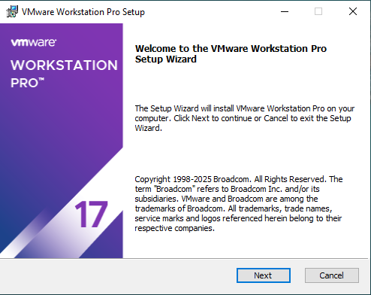

Step 2: Launching VMware Interface
After installation, I accessed the main dashboard where I could create and manage virtual machines.
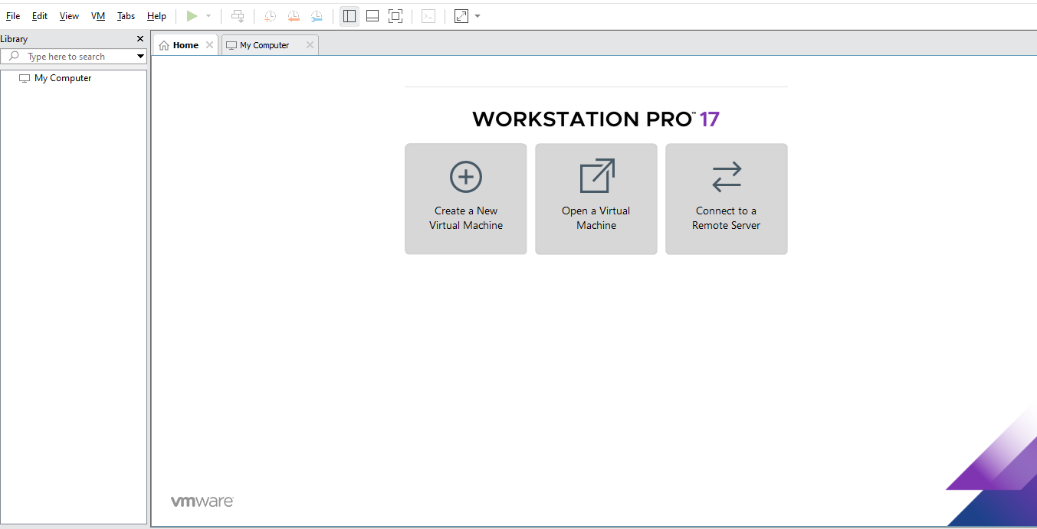
Step 3: Creating a New Virtual Machine
I created a new VM named “Windows Server 2022” and selected a custom location for storing VM files.
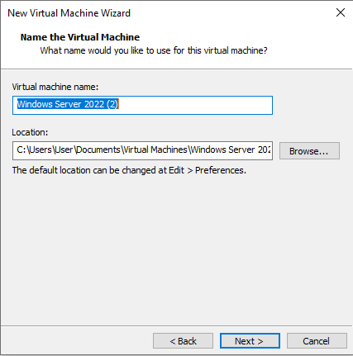
Step 4: Configuring VM Hardware
I allocated 20 GB RAM, 2 processors, and connected a network adapter to ensure smooth performance.
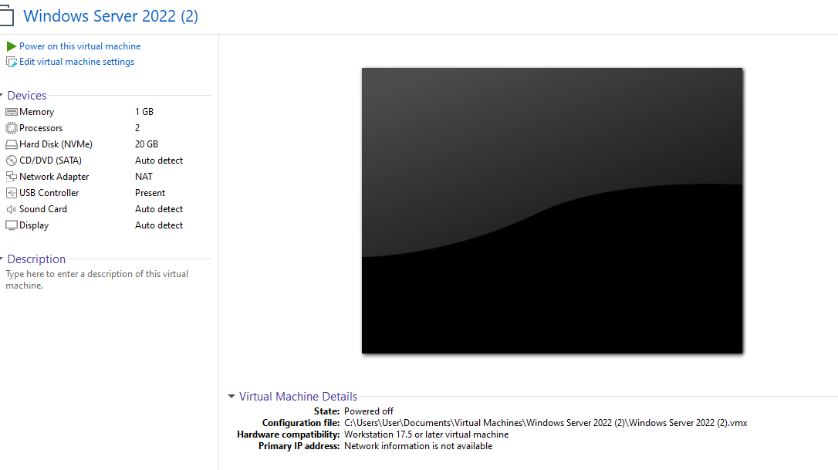

Step 5: Mounting the Windows Server ISO
I mounted the ISO file to install Windows Server 2022. This simulates how IT professionals deploy server environments.
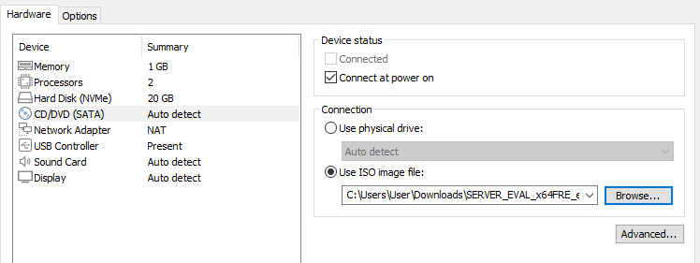
Step 6: Accessing Server Manager
After installation, I used Server Manager to configure roles and manage the local server.
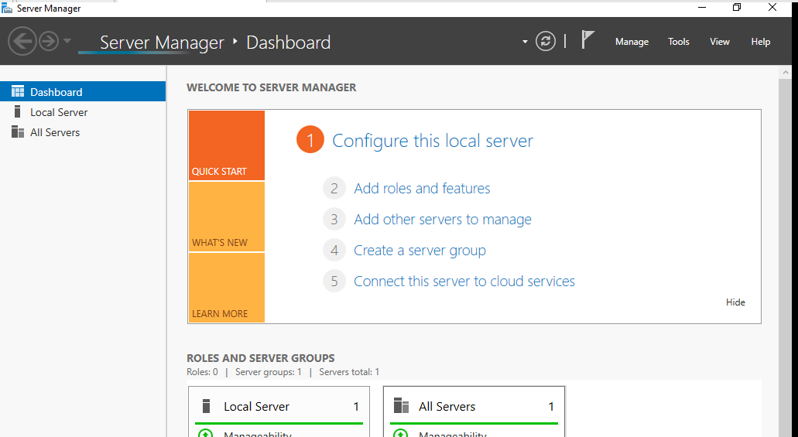
Step 7: Exploring Administrative Tools
The Start Menu provided access to key tools like ADUC, PowerShell, and Event Viewer.
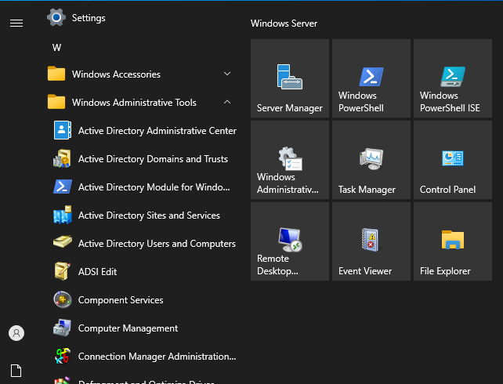

Step 8: Configuring Active Directory
I created a domain called “SammyMugisha.local” and structured it with geographic Organizational Units (USA, EUROPE, ASIA). Each OU contains subfolders for Users, Computers, and Servers.
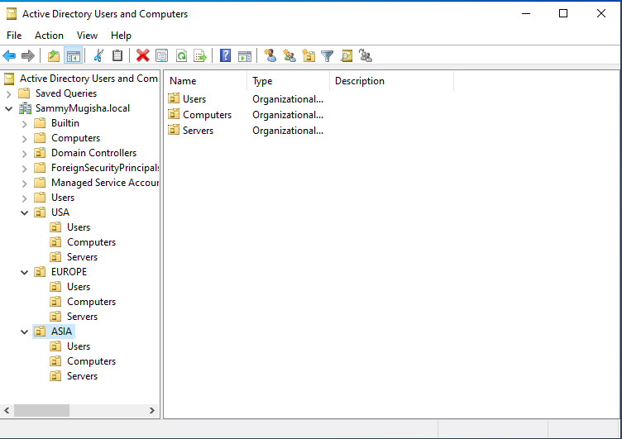
4. Outcomes
- Successfully created and configured a virtual Windows Server environment
- Practiced user and group management using Active Directory
- Applied Group Policies for desktop restrictions and access control
- Gained hands-on experience in virtualization and system administration

